42.33: a)
b) 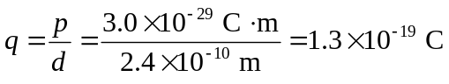
c) 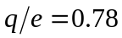
d) 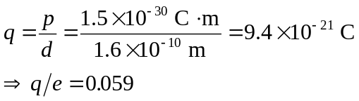
This is much less than for sodium chloride (part (c)). Therefore the bond for hydrogen iodide is more covalent in nature than ionic.

